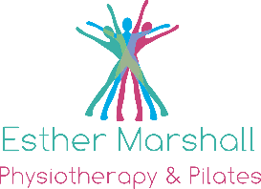
Online Pilates Classes with Esther
Why do Pilates with me?
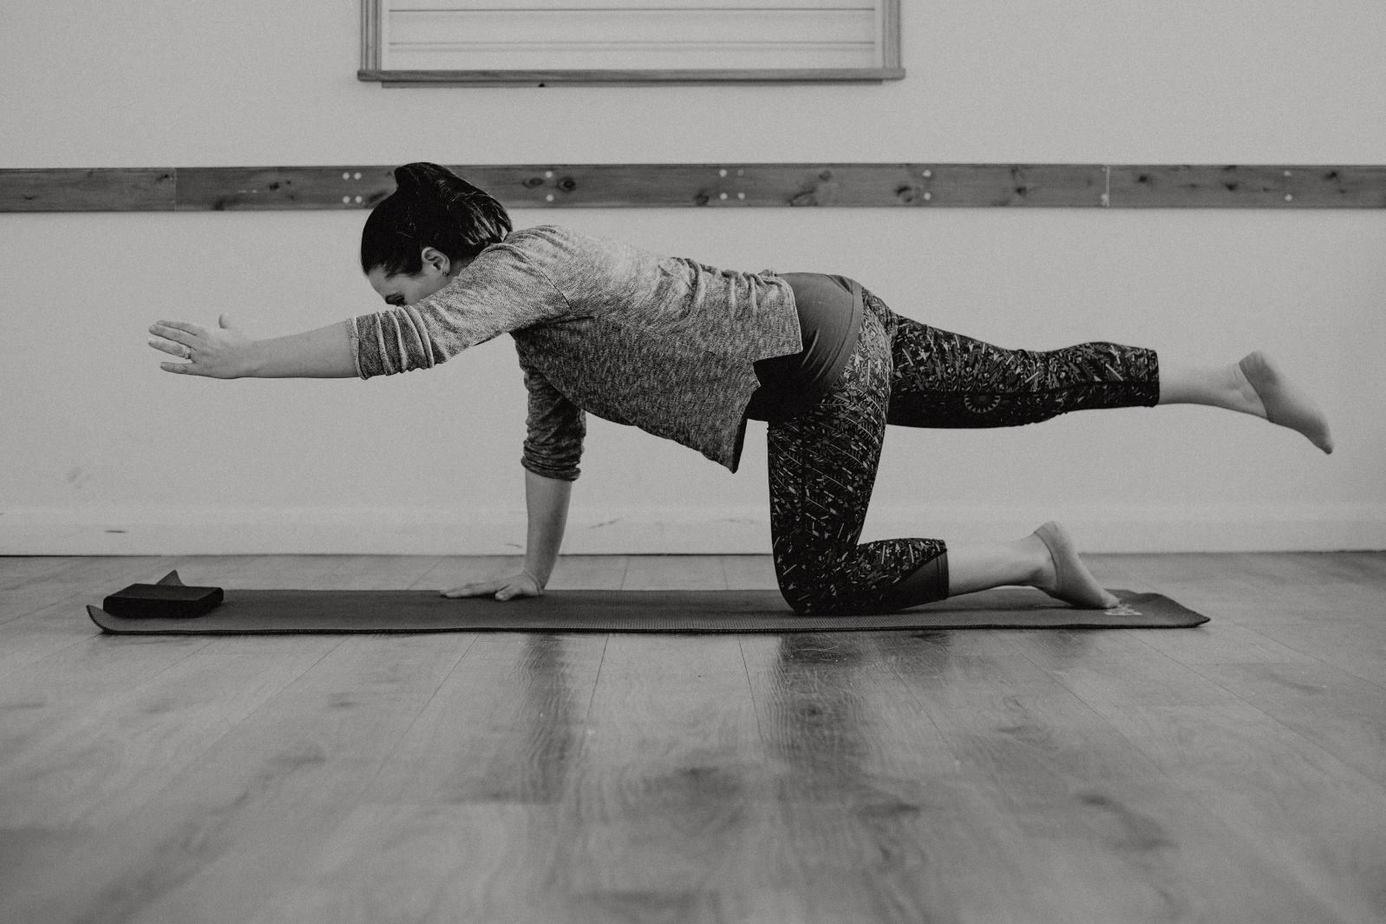
I love Pilates!
I believe Pilates is a brilliant way to ensure your body works effectively, efficiently, with great posture, strength, balance and alignment. Personally as a keen-(ish) runner, I have escaped any injuries or niggles thus far. I have also had 2 children and believe Pilates kept me fit and strong during my pregnancy, delivery and helped me to recover well afterwards.
I am a Physiotherapist with more than 15 years experience and have trained with the Australian Physiotherapy and Pilates Institute (APPI) who have developed Pilates for use within patient groups. I am very knowledgeable about what is good for your body particularly if you have any ongoing pain or injury. I have trained with the Australian Physiotherapy and Pilates Institute (APPI) who have developed Pilates for use within patient groups. I have also specifically trained to work with ladies who are pregnant and postnatally.
Is it suitable for me?
It is gentle on the body working from the deep core posture muscles out to the bigger power muscles. This means anyone can participate as long as you can lie on your back, front and side and be on hands and knees. It is beneficial for anyone recovering from or living with pain and injury right through to high level sports performers to make sure their bodies stay working well and minimise overuse injuries.
If you’re new to my Pilates classes I am offering a FREE 15-min “intro to Pilates” which I would like people to book into before participating in one of my regular classes. This will allow me to talk through, explain and practise the main elements of Pilates. It’s super important as the whole premise of Pilates works based on you being able to engage your core muscles, move precisely and hold your posture.

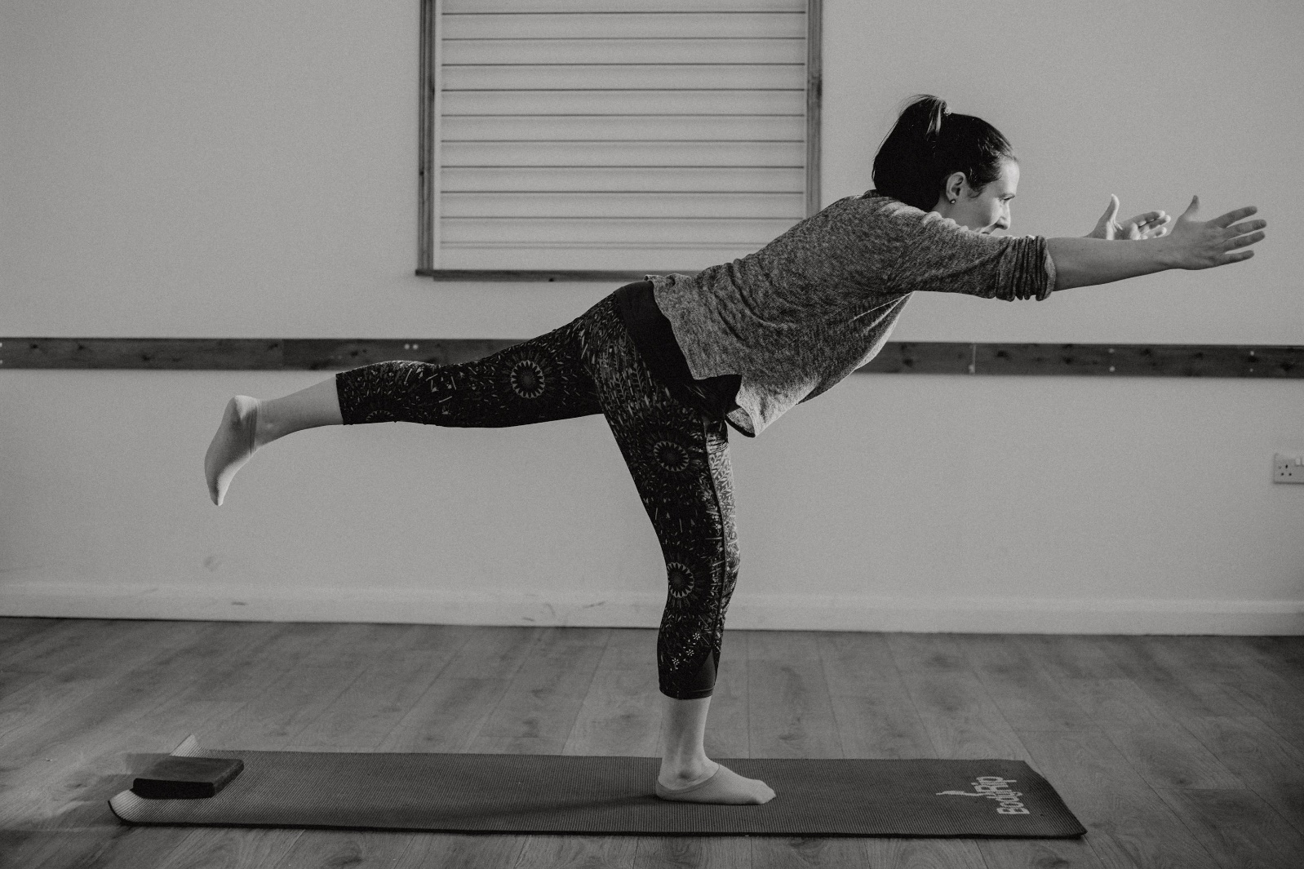
Pricing
I believe in the quality and precision of what I do, and as such I have previously charged for my classes based on the fact that I keep numbers low and I am able to physically interact with individuals enabling them to achieve more.
Unfortunately, taking the classes online detracts from my ability to do this and compromises what I believe Pilates is all about. Also, I’m aware that many people’s incomes are now reduced so I want to make this an affordable venture for everyone.

FREE – INTRODUCTION TO PILATES – 15 mins – max 8 people
This must be undertaken prior to joining in a class if you have never done Pilates with me before.
£5 - REGULAR CLASS 1 hour
Live online class where you will be able to see and hear me, but I will not be able to see or hear you. You will however be able to message me during the class. Bulk buying savings are available
£8 - EXCLUSIVE CLASS – 1 hour
Max 6 people. I will be able to see and hear you and offer specific feedback. Bulk buying savings are available.

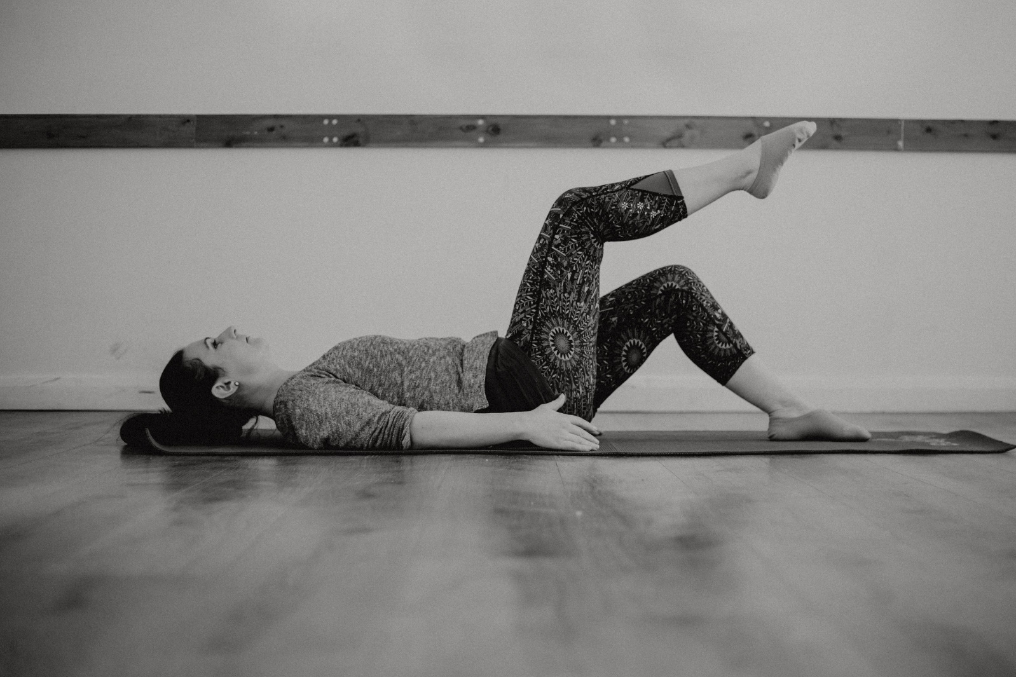
Timetable

DAY | TIME | TYPE | LEVEL
Monday | 7:30pm | REGULAR | SUITABLE FOR ALL
Wednesday | 7:30pm | EXCLUSIVE (Max 6) | ANTENATAL
Thursday | 7:30pm | REGULAR | SUITABLE FOR ALL

DAY | TIME | TYPE | LEVEL
Tuesday | 9:00 am | EXCLUSIVE (Max 6) | INTERMEDIATE
Tuesday | 10:15 am | REGULAR | SUITABLE FOR ALL
Tuesday | 11:30am | EXCLUSIVE (Max 6) | BEGINNER AND CLINICAL
Friday | 9:00 am | EXCLUSIVE (Max 6) | INTERMEDIATE
Friday | 10:15 am | REGULAR | SUITABLE FOR ALL
Friday | 11:30am | EXCLUSIVE (Max 6) | BEGINNER AND CLINICAL

A word of warning. My daytime timetable may have to be flexible. Currently my children are in a nursery Tuesdays and Fridays which allows me to work more easily. I am hoping they can continue here but may have to change things a little if they can’t. Please bear with me. Some very kind individuals have said they can join us, but they’re 2 and 3 years old so do not respond well to any given instructions and are prone to outbusrts of screaming, crying and jumping on people who are lying down! I can add more classes as the need arises so watch this space.
What do I need?
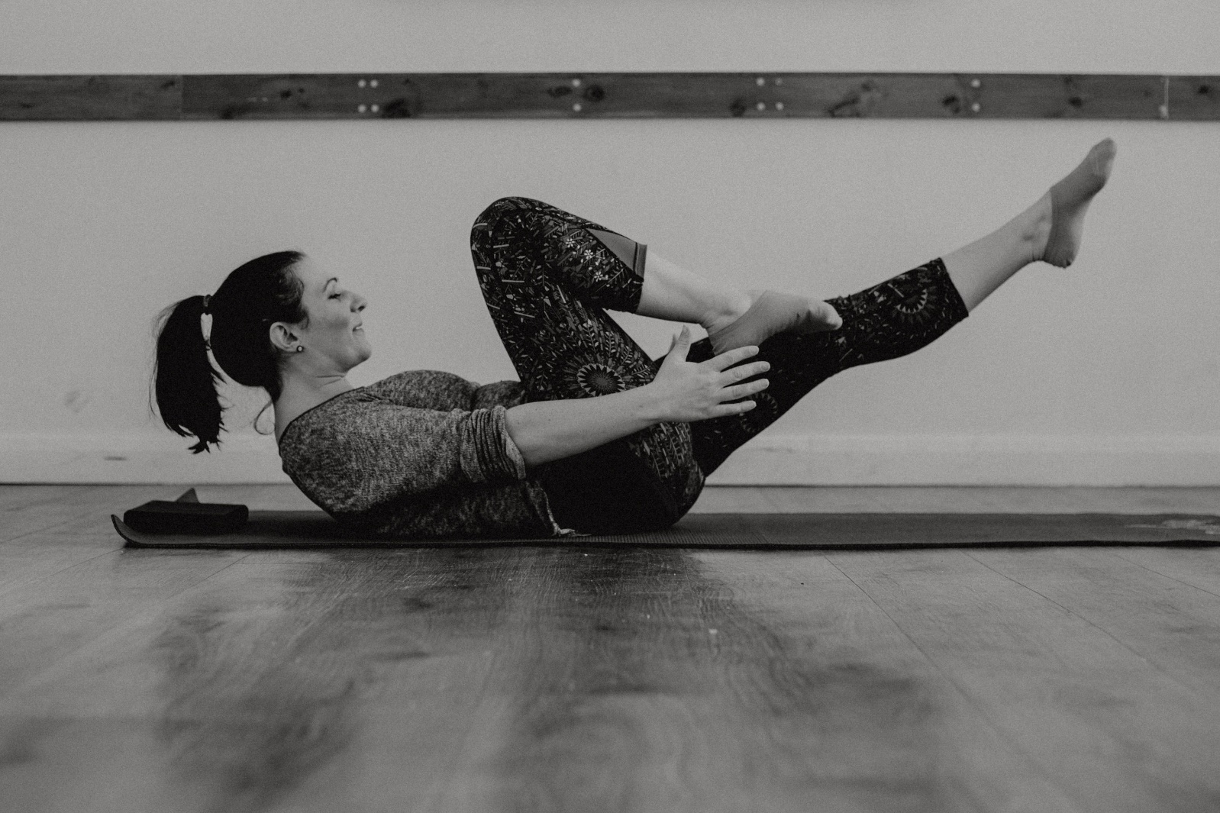
In order to join us you need:
An internet connection
A phone/tablet or computer
An account with Zoom (see below)
A mat (or carpet) and a small towel

How do I book?
Booking and payment etc can all be done via Wix Booking.
There is a Wix booking app which I recommend as it’s much easier than the website.
For the Wix booking app – download the app for phone/tablet for free. Use the invite code 2FLUUD to sign up with us.
To book online via laptop Online booking
Please ensure you fill in all our online forms to detail any relevant history or condition so we can make the class safe and effective for you.

Using ZOOM to access the class
Thankfully, this is super easy to use. Go to https://www.zoom.us/ to sign up or log in to zoom. You can use either on your laptop, tablet or phone. 15 minutes before each class, I will send out a “meeting code” for you to join our class for that day.

Any thoughts or questions, please do not hesitate to contact me on 07891719402, email: pilates.empp@mail.com
I look forward to seeing you in a class soon
Esther

